**Pig Commands**

First load the dataset using below commands

emp= load 'employee_details.txt' USING PigStorage(',') as (emp_id:int,emp_name:chararray,emp_salary:int,emp_rating:int);

1. Concat:

concat_emp= foreach emp generate CONCAT((chararray)emp_id,CONCAT('-',emp_name));

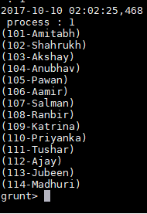

1. Tokenize:

line = load 'employee_details.txt' as (line:chararray);

token= foreach line generate TOKENIZE(line);

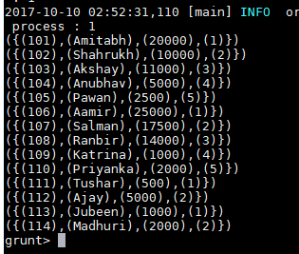

**emp_rank= group emp by emp_rating;**

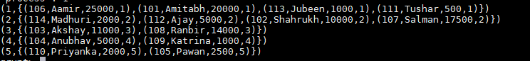

1. Sum

sum_per_rank = foreach emp_rank generate group, SUM(emp.emp_salary);

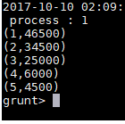

1. Min

min_per_rank = foreach emp_rank generate group, MIN(emp.emp_salary);

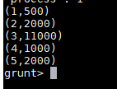

1. Max

max_per_rank = foreach emp_rank generate group, MAX(emp.emp_salary);

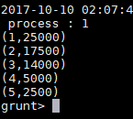

1. Limit

limit_five= limit emp 5;

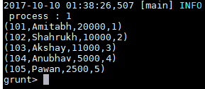

1. Store:

store emp into 'emp_store.txt';

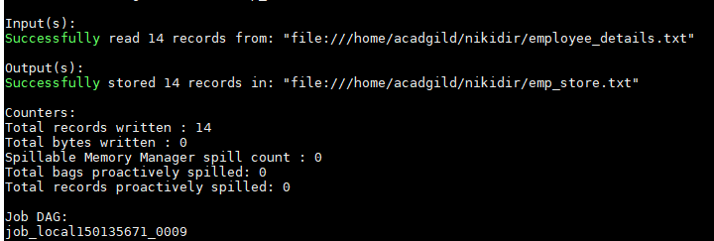

1. Distinct

only_rating= foreach emp generate emp_rating;

distinct_rating= distinct only_rating;

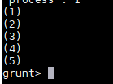

1. Flatten:

flat_rank= foreach emp_rank generate group, flatten(emp);

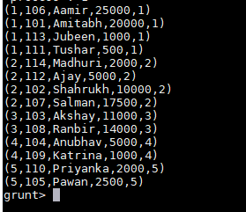

1. IsEmpty

filter_emp = filter emp_rank by **not** IsEmpty(emp);

